# Using R Markdown programs created by Activinsights.

The following tutorial gives a demonstration on how to use R and RStudio, run sleep analysis and various other Markdowns created by Activinsights Limited. In this example tutorial the sleep markdown will be unpacked from a zip folder and run using a GENEActiv .bin file. The output will be analysed, and this will be updated throughout

## Computer Specifications

To run the markdowns the following **minimum** specifications are required:

* 2.5GHz processor
* 8Gb RAM.

## Setting up the correct programs

Firstly, download R or check that you have the latest version. If you do not have the latest version, please update your version of R.

<https://www.r-project.org/about.html>

RStudio is an integrated development environment which is designed to make using R easier.

Please download it here:

<https://www.rstudio.com/products/RStudio/>

## Unpacking files from the zip folder.

Once you have downloaded and installed RStudio please take the zip folder you were sent and unpack the folder.

The folder should look like this.

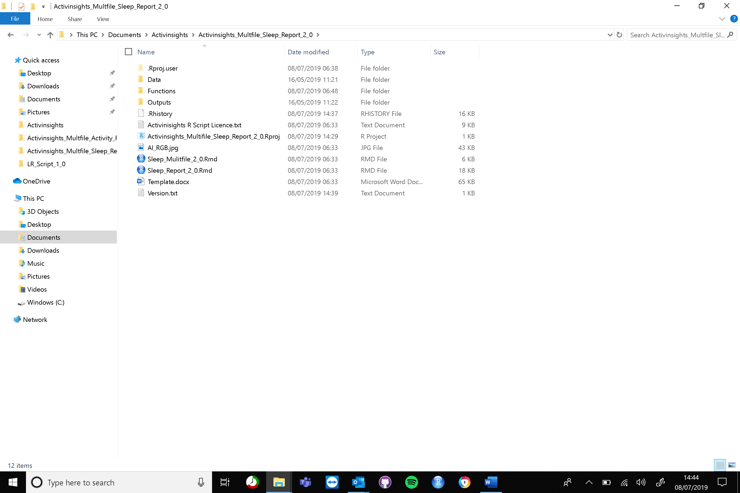

For each file you wish to analyse, drop the bin files folder into the data folder.

To open the markdown analysis select the .Rproj file and open using RStudio. This can be done by double clicking or right-click, select open with and select RStudio.

Once open, this screen will open:

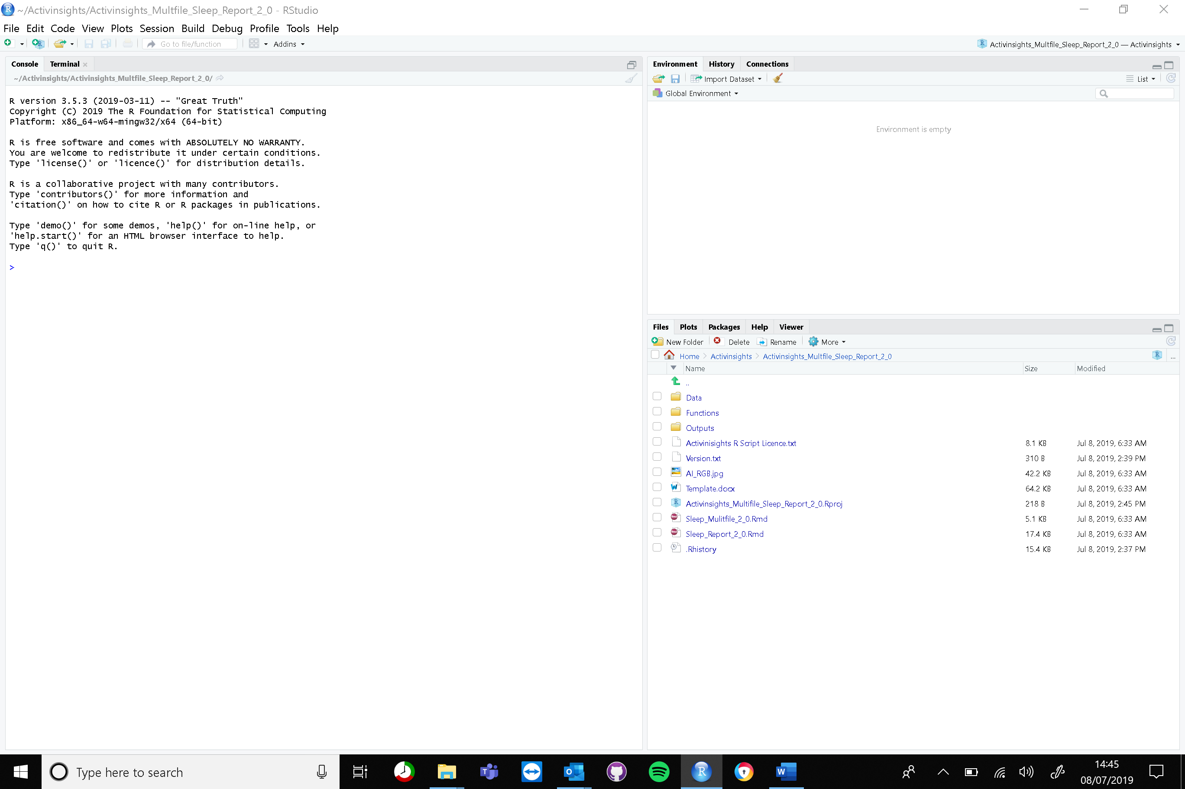

Once you have unpacked the folder you should be able to open the Sleep_Multifile_2_0.rmd within RStudio. To run the markdown simply press the knit button shown in the screenshot below. This will create a word sleep report, an excel csv file of the summary metrics and a excel csv file of the classified data in the outputs folder. A word document called Multfile_2_0 that summarises the GENEActiv .bin files that were analysed can be found in the root folder.

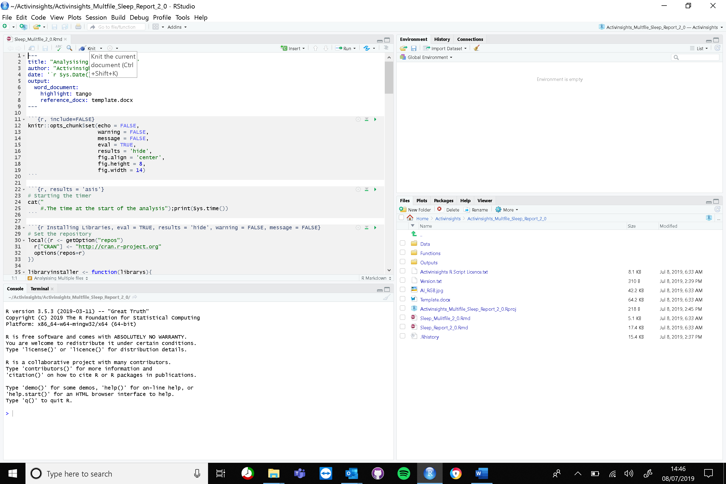

## Changing the changepoint cut points:

To increase/decrease the number of segments found, go to the the functions folder inside RStudio

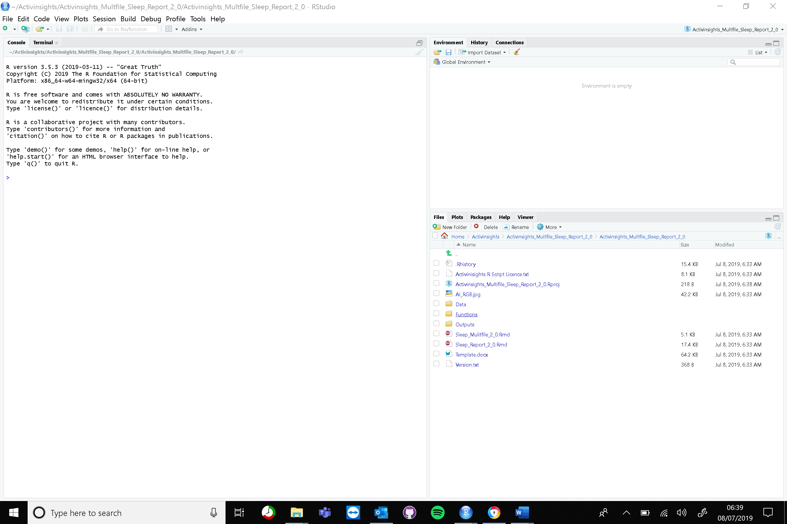

You’ll find the following files:

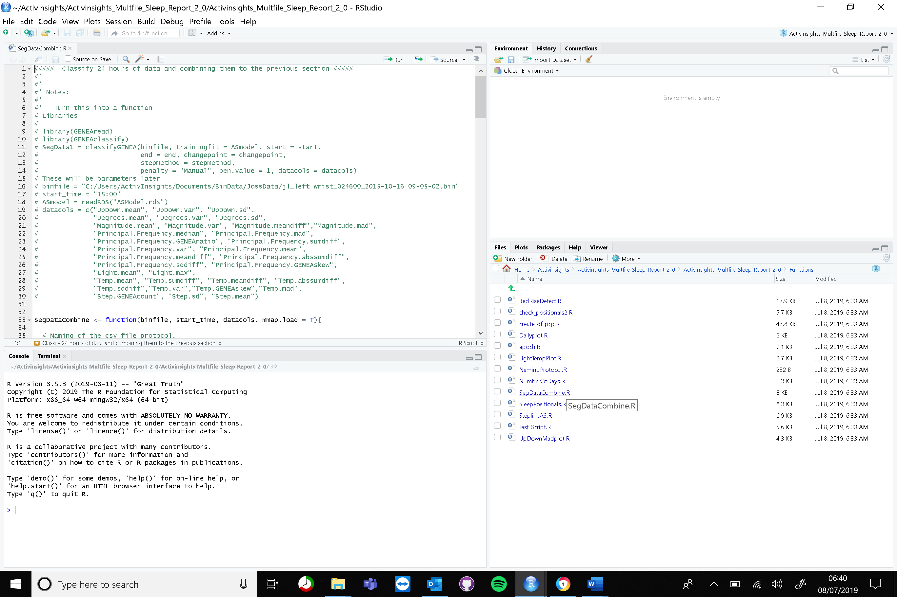

Select the files SegDataCombine.R and go to line 42 and 43. This is the function used to segment the data. To increase/decrease the number of segments on the UpDown changepoint vary pen.value1 by less/more. To increase/decrease the cutpoints on Degrees vary pen.value2 by less/more.

## Changing the step counting parameters:

To increase/decrease the number of steps found, lower/rise the value of Step_Threshold the step parameters, alter the line 60.